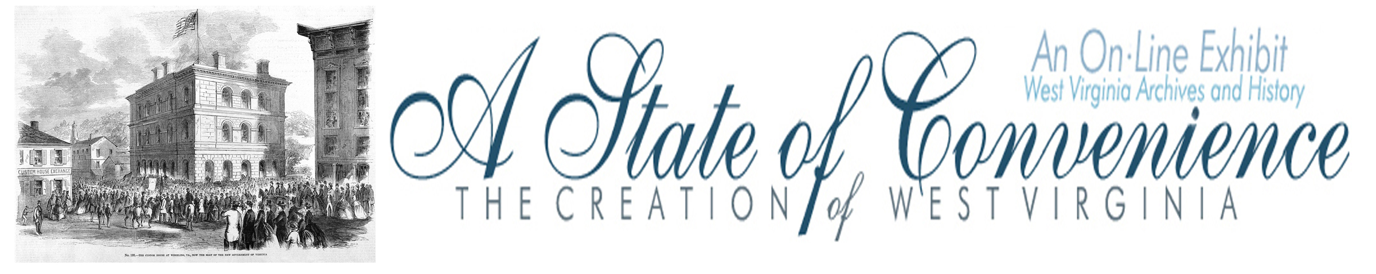

Name ______________________________________ Date _______________ Period ________

East vs. West
Writing Exercise
Directions: Go to http://www.wvculture.org/history/statehood/statehood01.html and pick one of the following writing assignments. Use the back of this sheet to complete the writing prompt.

1. In 1803 Harrison County Delegate John G. Jackson penned a letter to the Richmond Examiner under the pseudonym “A Mountaineer” to complain about property qualifications for voting and the unbalanced representation in Virginia. Write a letter to the Charleston Gazette under the pseudonym “A Mountaineer” about an issue that you are concerned about today.

2. In 1816 and 1825 delegates from western Virginia met in Staunton to discuss changes that they wanted to come to Virginia. Write a letter to a friend or family member about the changes that took place at these conventions and the impact that these new changes could have for western Virginia.

3. After the passage of the 1830 Virginia Constitution westerners were very upset because their demands were not included in the new constitution. Write a letter to the editor of the Kanawha Republican about the problems that were not addressed in the new constitution.

4. In 1850 the Reform Convention meeting in Richmond passed constitutional reforms that were appreciated in western Virginia. Write a letter to your business partner in Wheeling explaining the changes that have finally come to Virginia.

