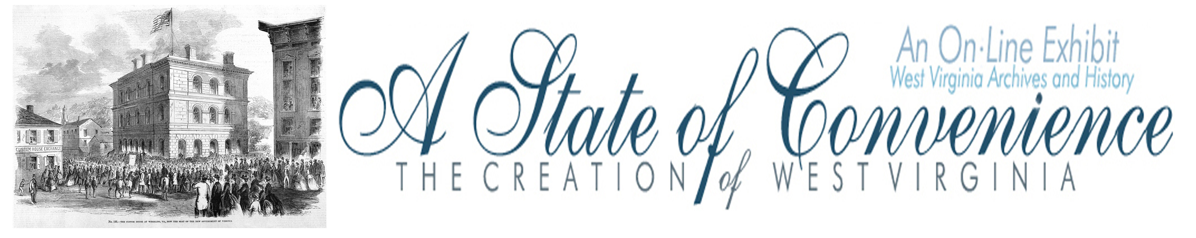

Name ______________________________________ Date _______________ Period ________

The Richmond Convention

Directions: Go to http://www.wvculture.org/history/statehood/statehood03.html and answer the following questions.

1. When was the Richmond Convention held?

2. Why was the convention held?

3. How many delegates attended the convention?

4. What was the general mood of the convention in February, March and April of 1861?

5. What event changed the mood of the convention?

6. What action by President Lincoln resulted in calls for the Virginia Ordinance of Secession?

7. What was the vote total concerning the Virginia Ordinance of Secession?

8. From where were the delegates from who voted against the ordinance?

Answer Key
The Richmond Convention

1. When was the Richmond Convention held?

The convention was held between February 13 and April 17, 1861.

2. Why was the convention held?

The convention was held to determine Virginia’s course in the secession crisis.

3. How many delegates attended the convention?

There were 152 delegates to the Richmond Convention.

4. What was the general mood of the convention in February, March and April of 1861?

The general mood of the convention was against secession.

5. What event changed the mood of the convention?

The surrender of Fort Sumter to Confederate forces changed the mood of the convention.

6. What action by President Lincoln resulted in calls for the Virginia Ordinance of Secession?

President Lincoln called for 75,000 troops to put down the rebellion.

7. What was the vote total concerning the Virginia Ordinance of Secession?

The vote total for secession was 88 with 55 voting against secession.

8. From where were the delegates from who voted against the ordinance?

The delegates voting against secession were from western Virginia.

