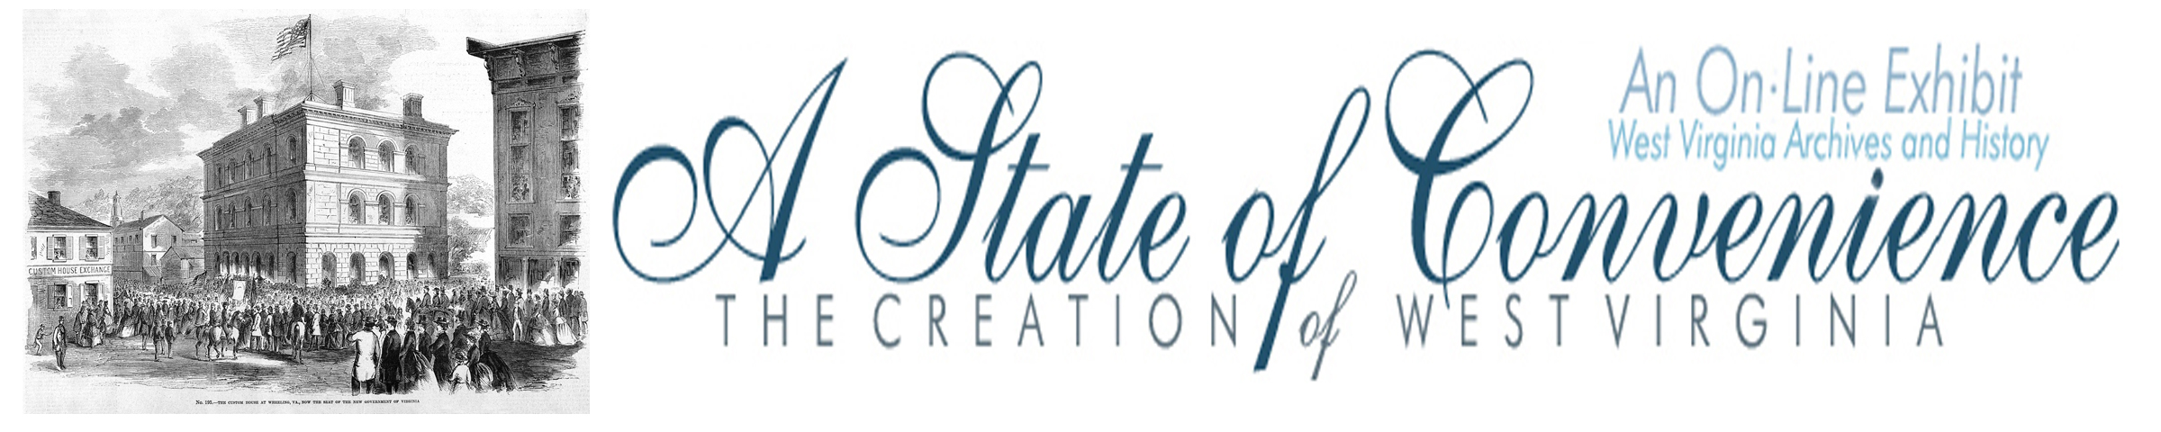

Name ______________________________________ Date _______________ Period ________

The First Wheeling Convention

Directions: Go to http://www.wvculture.org/history/statehood/statehood05.html and answer the following questions.

1. When was the first Wheeling Convention held and where did the delegates meet?

2. How many counties were represented?

3. What was the major purpose of the convention?

4. What was the first debate at the convention? How was the problem solved?

5. During the convention what were the two major positions and who were the main supporters of each?
Position 1 | Main Supporters
Position 2 | Main Supporter
6. When was the statewide vote on the Order of Secession?

7. What did the convention decide to do if the Order of Secession passed?
Answer Key
The First Wheeling Convention

1. When was the first Wheeling Convention held and where did the delegates meet?

The first Wheeling Convention was held May 13 – 15, 1861. The convention met at Washington Hall in Wheeling.

2. How many counties were represented?

Twenty-seven counties were represented at the meetings.

3. What was the major purpose of the convention?

The purpose of the convention was to consider and respond to the Order of Secession presented at Richmond.

4. What was caused the first debate at the convention? How was the problem solved?

The first debate at the convention was to determine how counties should be represented and who would serve in the body. The issue was solved by the creation of a Committee on Representation and Permanent Organization.

5. During the convention what were the two major positions and who were the main supporters of each?
Position 1 | Main Supporters
Wait for the statewide vote | General John Jay Jackson, Waitman T. Willey
Position 2 | Main Supporter
The creation of a New State | John S. Carlile
6. When was the statewide vote on the Order of Secession?

May 23, 1961

7. What did the convention decide to do if the Order of Secession passed?

The convention decided to meet in Wheeling on June 11, 1861

