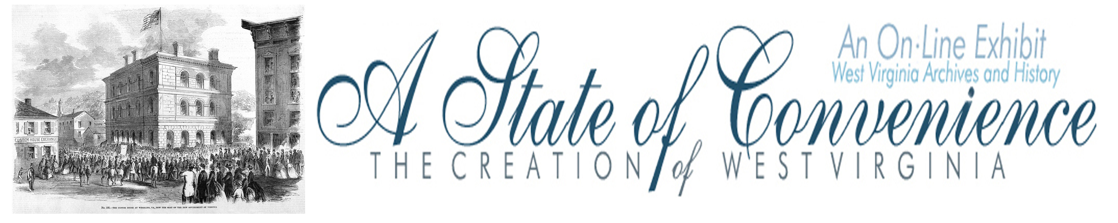

Name ______________________________________ Date _______________ Period ________

Ratification of the Ordinance of Secession

Directions: Go to http://www.wvculture.org/history/statehood/statehood06.html and answer the following questions.

1. When was the statewide vote on the Ordinance of Secession held?

2. Why was the vote merely a technicality?

3. What was the statewide outcome of the Ordinance of Secession vote?

For Secession | Against Secession

4. Why were many western Virginians outraged?

5. Go to “The Election News” from the Wellsburg Herald at http://www.wvculture.org/history/statehood/oofsvote.html and answer the following questions.

According to the news story:

a. Which county had the most total votes?

b. Which county had the least total number of votes?

c. Which county had the most votes against secession?

d. Which county had the most votes for secession?

e. From the list, how many of the counties listed were against secession?

6. At the bottom of the articles is a list of names. Why were the people listed?

7. Why might being on this list be a bad thing?

8. Which side of the vote do you think the Wellsburg Herald was on? What evidence would you give to support your answer?

9. According to this cartoon that appeared in Harper’s Weekly how was Virginia voted out of the Union?
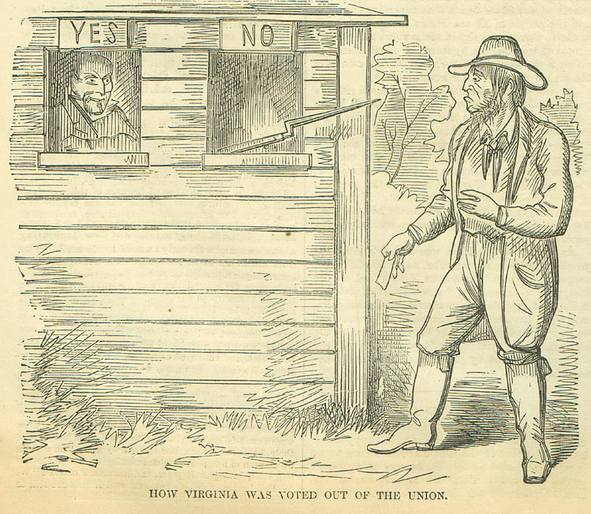

Answer Key
Ratification of the Ordinance of Secession

1. When was the statewide vote on the Ordinance of Secession held?

May 23, 1861

2. Why was the vote merely a technicality?

The vote was merely a technicality because the government of Virginia had already aligned itself with
the Confederacy.

3. What was the statewide outcome of the Ordinance of Secession vote?

For Secession | Against Secession
125,950 | 20, 373

4. Why were many western Virginians outraged?

Many western Virginians were outraged because many of the votes from western Virginia were not
delivered to Richmond.

5. Go to “The Election News” from the Wellsburg Herald at http://www.wvculture.org/history/statehood/oofsvote.html and answer the following questions.

According to the news story:

a. Which county had the most total votes? Ohio

b. Which county had the least total number of votes? Pleasants

c. Which county had the most votes against secession? Ohio

d. Which county had the most votes for secession? Harrison

e. From the list, how many of the counties listed were against secession? 23

6. At the bottom of the articles is a list of names. Why were the people listed?

This is a list of people who voted for secession.

7. Why might being on this list be a bad thing?

It would be bad to be on this list because people could retaliate against you.

8. Which side of the vote do you think the Wellsburg Herald was on? What evidence would you give to support your answer?

The Wellsburg Herald was against secession. There are various answers, but the names of people who voted for secession, the words Southern conspiracy, and others.

9. According to this cartoon that appeared in Harper’s Weekly how was Virginia voted out of the Union?

According to this cartoon Virginia was voted out of the Union through intimidation and the threat of violence.

