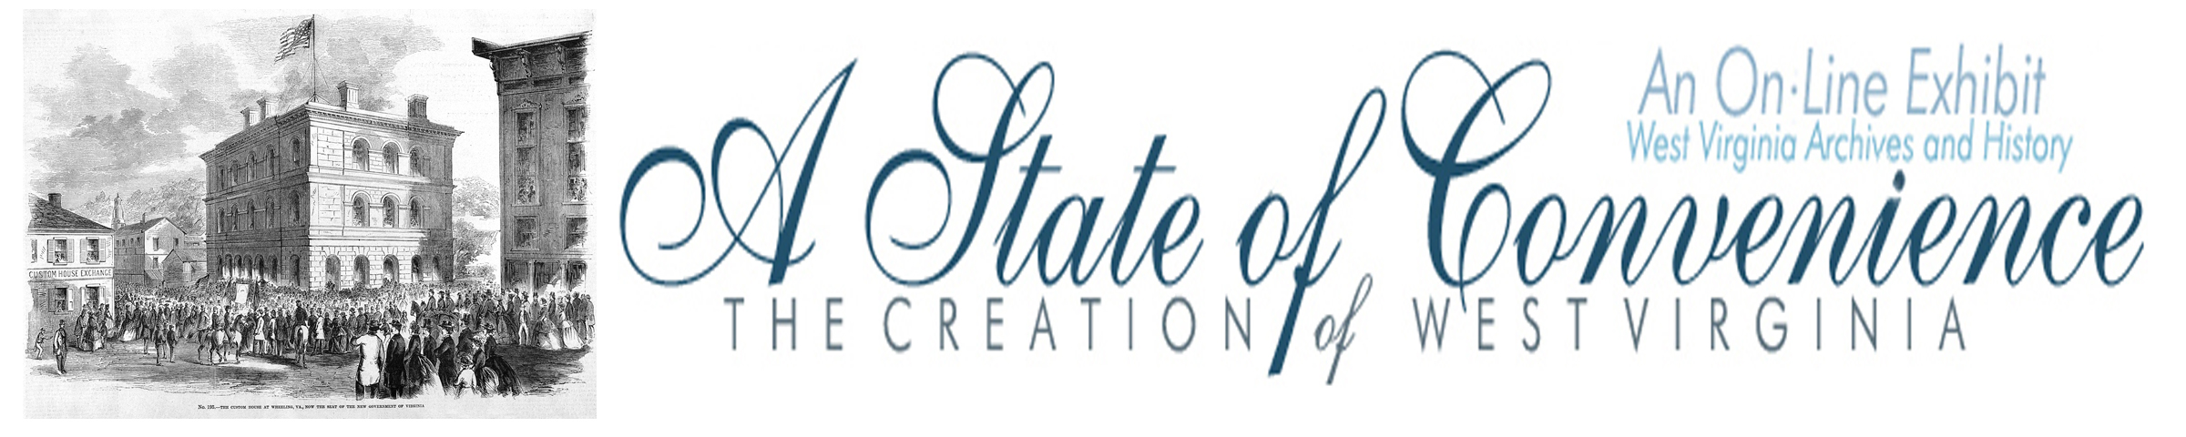

Name ______________________________________ Date _______________ Period ________

Statehood Referendum

Directions: Navigate to http://www.wvculture.org/history/statehood/statehood10.html and answer the following questions.

1. What is a referendum?

2. How many counties voted in the statehood referendum? (Hint: be sure to include counties that were a part of the original statehood proposal.)

3. What was the voter turnout percentage for the statehood referendum? Was this high or low?

4. What reasons do you think led to turnout percentage in the question above?

5. How many people voted for the new state?

6. How many people voted against statehood?

7. What did voters also decide during this election?

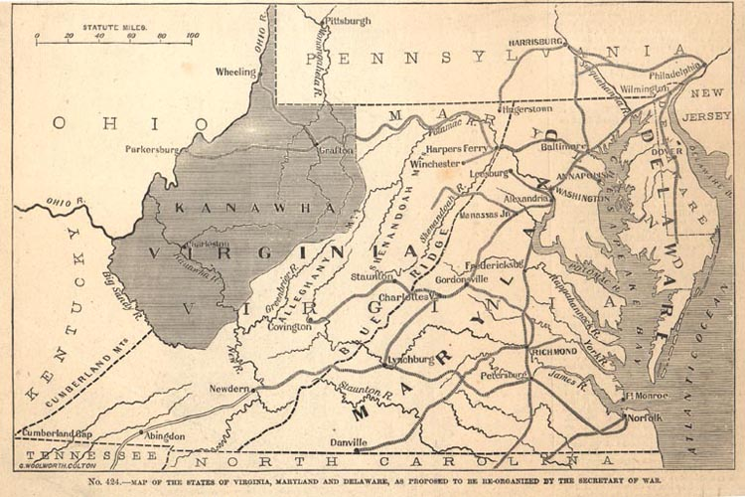

1862 Map Showing the Proposed State of Kanawha Frank Leslie's Pictorial History of the American Civil War, 1862 (Ma61- 25)

8. What part of modern West Virginia is missing from the proposed state of Kanawha above?

Statehood Referendum

Answer Key

1. What is a referendum?

A referendum is a direct vote of the people to approve major changes to a state’s laws or territory.

2. How many counties voted in the statehood referendum? (Hint: be sure to include counties that were a part of the original statehood proposal.)

41

3. What was the voter turnout percentage for the statehood referendum? Was this high or low?

34%, voter turnout was low for this election.

4. What reasons do you think led to turnout percentage in the question above?

Students could give various answers. Possible answers: Civil War, people were afraid to vote,
many of the voters were serving in the military and weren’t home to vote, women and African-
Americans could not vote.

5. How many people voted for the new state?

18,408

6. How many people voted against statehood?

781

7. What did voters also decide during this election?

Voters also picked delegates to the new state’s constitutional convention.

8. What part of modern West Virginia is missing from the proposed state of Kanawha above?

The eastern panhandle and Greenbrier Valley are missing from the map.

