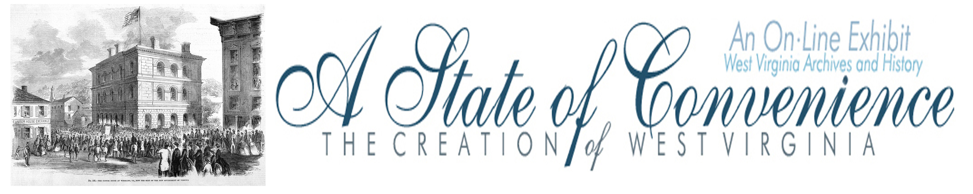

Name ______________________________________ Date _______________ Period ________

Lincoln’s Dilemma

Directions: Navigate to http://www.wvculture.org/history/statehood/statehood14.html and answer the following questions.

1. When did President Lincoln receive the West Virginia Statehood Bill?

2. What did Lincoln do after he received the bill?

3. How did the six reviewers vote?

4. How did Lincoln feel about the bill?

5. What reasons did Lincoln give for signing the bill?

6. When did Lincoln sign the West Virginia Statehood Bill?

Lincoln’s Dilemma

Answer Key

1. When did President Lincoln receive the West Virginia Statehood Bill?

December 22, 1862.

2. What did Lincoln do after he received the bill?

He asked six members of his cabinet to review the bill and give him their opinion on the legality of
the West Virginia Statehood Bill.

3. How did the six reviewers vote?

Three supported the bill and three disagreed with the bill.

4. How did Lincoln feel about the bill?

He had deep reservations about the bill.

5. What reasons did Lincoln give for signing the bill?

He could not afford to lose the support of West Virginia.
West Virginians risked it all to support the Union and deserved his support.

6. When did Lincoln sign the West Virginia Statehood Bill?

December 31, 1862.

