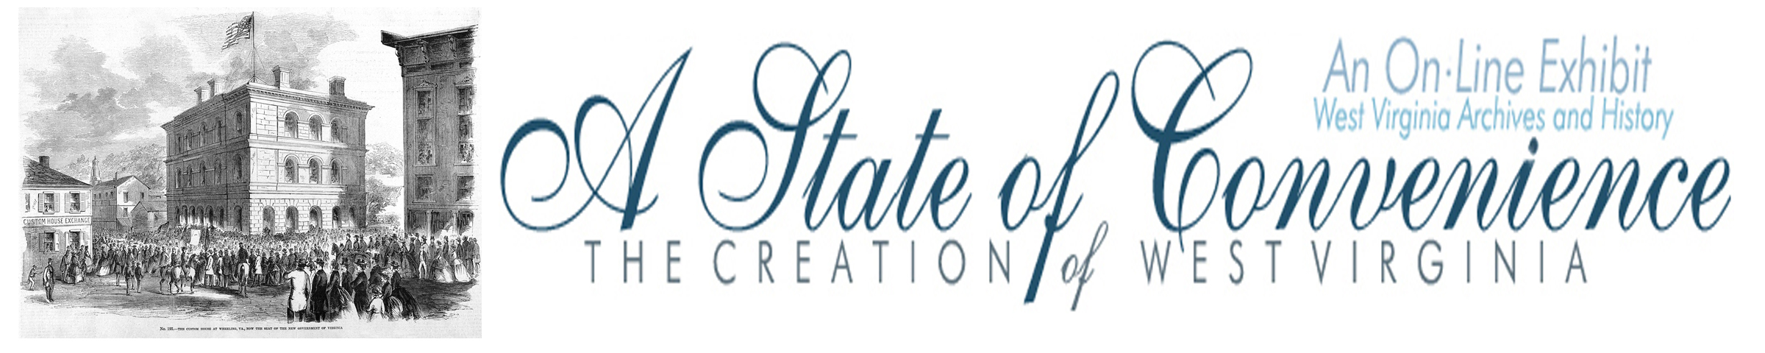

Name ______________________________________ Date _______________ Period ________

West Virginians Approve the Willey Amendment

Directions: Navigate to http://www.wvculture.org/history/statehood/statehood15.html and answer the following questions.

1. What conditions were West Virginians required to meet before the new state could be formed?

2. What did the Willey Amendment do?
(Hint: go to http://www.wvculture.org/history/statehood/willeyamendment.html)

3. On what day did West Virginia vote on the proposed changes (the Willey Amendment)?

4. What were the totals for the vote?

For ________ Against _______

5. What did President Lincoln do following the results of the election?

West Virginians Approve the Willey Amendment

Answer Key

1. What conditions were West Virginians required meet before the new state could be formed?

They had to approve the Willey Amendment and make changes to the state constitution to reflect
the Willey Amendment.

2. What did the Willey Amendment do?
(Hint: go to http://www.wvculture.org/history/statehood/willeyamendment.html)

The children of slaves born within the limits of this State after the fourth day of July, eighteen hundred and sixty-three, shall be free; and all slaves within the said State who shall, at the time aforesaid, be under the age of ten years, shall be free when they arrive at the age of twenty-one years; and all slaves over ten and under twenty-one years, shall be free when they arrive at the age of twenty-five years; and no slave shall be permitted to come into the State for permanent residence therein.

3. On what day did West Virginia vote on the proposed changes (the Willey Amendment)?

March 26, 1863

4. What were the totals for the vote?

For ___28,321_____ Against __572__

5. What did President Lincoln do following the results of the election?

He issued a proclamation on April 20 declaring that in 60 days, or June 20, West Virginia would
become the 35th state in the Union.

